Realtime data from ODIN TO AMIBROKER, FCHARTS

1Preface 2

2System Requirements 2

3Setup 3

4Setup for AmiBroker Users- 3

GETTING REAL TIME DATA FEED TO EXCEL 4

5Getting Realtime Feed to AMIBroker 6

6Realtime feed to FCharts.......... 6

7Backfill with ODIN 7

8Backfill with Data Downloader 8

9Troubleshooting 10

# Preface

1. This utility was originally developed to feed real time quotes from NOW (Neat on Web) to Amibroker and distributed it freely with source code. After using it for some period, it was realised that with some further coding, it can be used to feed real time quotes from NEST, ODIN, Trade Tiger, Google and Yahoo to charting applications like Amibroker, Fcharts Qtstalker and Metastock also. This utility was upgraded to various versions. and now it has become stable.
2. The utility gives RT quotes in Ami from the time you click on- Start. It does not give RT from beginning of the day. So start RT and then open backfill. Copy data upto the time you logged in into Backfill. When backfills warns you, save database and do backfill. Your data will be current.
3. You do not have to record any excel macro.
4. Since you are reading this, it means you have downloaded the zip file containing the utility and extracted it. This help file is accompanied by following files. Use the files appropriate for your setup.
5. RTOdin.xlsm – Real time feed from Odin
6. OdinBackfil – Backfill from ODIN
7. Nest3.format – This file is used by Amibroker to import backfill data
8. RTG3.format– This file is used by Amibroker to import real time data
9. Arbitrage.xlsm – Sample for ODIN users

# System Requirements

1. Minimum requirement is Excel 2007 – 32 bit and Windows XP or above.
2. Tested on Windows XP and Windows 2003 x64 Server, Windows 8 , Windows 7.

# Setup

1. There are two stages involved in getting real time charts with this utility.  
     
   First - Getting the realtime feed from Trading software or Google/Yahoo to Excel.  
     
   Second - Getting the realtime feed from Excel to Charting software.
2. Files of type *.xlsm can be kept anywhere in a separate folder. However, I recommend keeping them wherever your Trading Software/application resides.
3. Files of type *.format ( Nest3.format and RTG3.format ) should be moved to 'Your\Path\to\Amibroker\format folder' since Amibroker requires them there.
4. Open Excel. Click on the Office icon on top left test
5. Click on **Excel Options- Trust Center - Trusted Locations - Add New Location** and give the path of folder where your Trading Software resides. Also give the path of folder where you kept the *.xlsm files. For example, if you have kept the excel files on 'desktop\RTNOW' folder, then include that folder in trusted loactions. This way, excel will open the .xlsm file with macros enabled. Otherwise, you will have to enable macros every time.

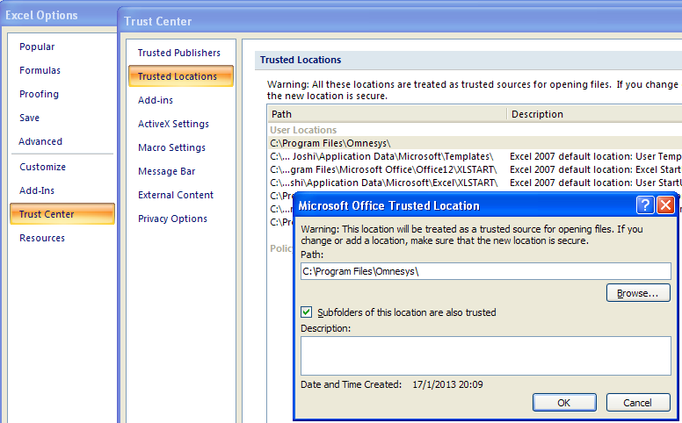

# Setup for AmiBroker Users-

1. Before trying anything in AmiBroker, create new database e.g. C:\AmiBroker\RTdata.
2. Give database folder path to create database. Thereafter, do all the settings as shown above. Those who want to combine EOD data should check against -Allow mixed EOD/Intraday data in Intraday settings.
3. **GoTO Tools Preferences-Do settings in preferences as shown below.**

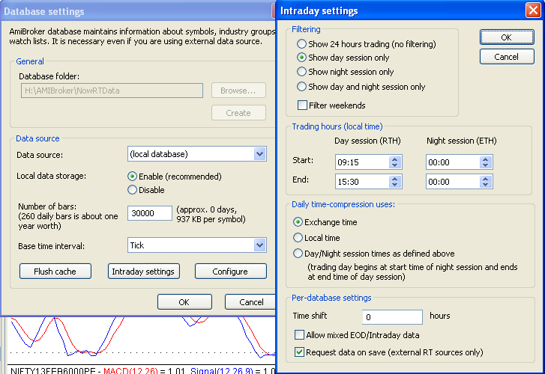

# GETTING REAL TIME DATA FEED TO EXCEL

1. **Please note that ODIN ver 10.0.0.2 is minimum requirement. Versions before that do not have capability of Open to Excel**.
2. There are three stages for getting RT feed in Ami from ODIN.

1. Getting RT feed in Arbitrage.xls from ODIN.

2. Getting RT feed from Arbitrage.xls to RTOdin.xlsm

3. Getting RT feed from RTOdin.xlsm to AmiBroker.

**1. Getting RT feed in Arbitrage.xls from ODIN.**

1. Login to Odin and open the desired market watch
2. Right click in the market watch and select “open in ms-excel”
3. Small box appears asking for select sheet. Select sheet1
4. **A file named Arbitrage.xls will open with all the scripts/futures/options and you will see the rates changing. This is your source.**

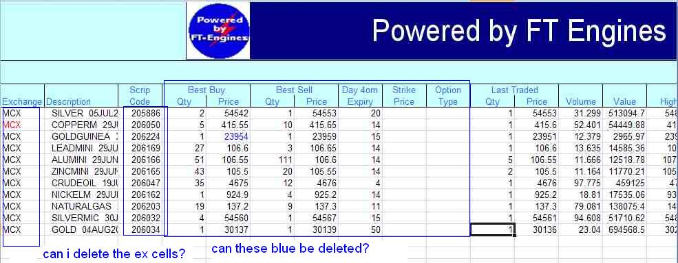

**2. Getting RT feed from Arbitrage.xls to RTOdin.xlsm**

1. Click on Office Icon and Open RTOdin.xlsm from within same instance of Excel. Change the database path to Your\Database\folder\Path.
2. We want **Trading Symbol, Last Trade Time, Last Traded Price, Last Traded Qty, Open interest in columns A, B, C, D, E respectively**. Therefore,  
   **In Cell A7 type "=[Arbitrage.xls]Sheet1!B2", (Replace B2 with cell reference for Description in Arbitrage)  
   In Cell B7 type "=text (Now(), “HH:mm:ss”) , (Odin does not give trade time so we use system time)  
   In Cell C7 type "=[Arbitrage.xls]Sheet1!L2", (This is normally Last Price in Arbitrage)  
   In Cell D7 type "=[Arbitrage.xls]Sheet1!M2", (This is normally Volume in Arbitrage)  
   In Cell E7 type "=[Arbitrage.xls]Sheet1!N2",**
3. Sample Arbitrage file is provided. RTOdin contains sample formulae for linking.
4. **If you see the rates changing, you are done.**
5. If Excel does not allow linking like this, Open Excel by clicking Start-Programs-Microsoft Office-Excel2007 and Click on Office Icon and Open RTOdin.xlsm from that instance.
6. If you see $ signs in cell reference, remove them. Copy the entire row in four rows below. You should see other scrips and their changing prices. Check the format of the columns once. Column B should have Time format and columns C, D, E should have number format.
7. If you are not getting Open Interest in ODIN, Keep that column empty. Open the RTG3.format file in notepad.  
   Change the line - $FORMAT Ticker, Time, Close, Volume, OpenInt, Skip  
   to this - $FORMAT Date_MDY, Ticker, Time, Close, Volume, Skip, Skip   
   and save.

**3. Getting RT feed from RTOdin.xlsm to AmiBroker.**

1. Change the database path in Cell B1 to Your\AMIBROKER Database\folder\Path
2. **If you installed RAM disk, then give Drive Letter in Cell B2 other wise leave it blank.**
3. **Click on “Start RT Data”.**
4. **AmiBroker Should open automatically and you will see live charts moving**
5. **Once you start getting data feed in AMIBroker, save the arbitrage.xls in ODIN folder. Next time, open/load the same arbitrage.xls file. Otherwise you will not get realtime feed.**

# Getting Realtime Feed to AMIBroker

1. Once you start getting realtime quotes in Excel, next step is to get them in AmiBroker and see the charts moving. Your source can be any of NOW, Odin. Trade Tiger, Yahoo or Google. Method of feeding data to AmiBroker is similar. Here is a snapshot of RTNOW.xlsm.
2. **If you installed RAM drive, then give Drive Letter in Cell B2 other wise leave it blank . If you are not sure what is RAM Drive, keep this field blank**
3. **Give Your\Database\Path in cell B1.**
4. **Click on “Start RT Data”.**
5. **AmiBroker Should open automatically and you will see live charts moving**

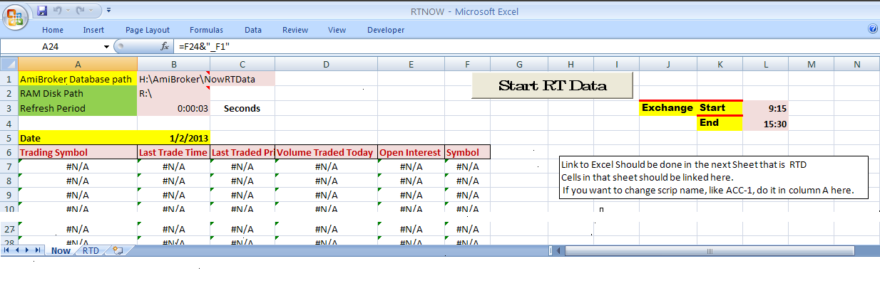

# Realtime feed to FCharts..........

1. FCharts is another application for stock charting. There are two versions of this application. 1. FChartSE is free for all users and 2. FChartPRO is paid versions. I had used the free version about two years ago. I found some discrepancies in weekly charts. That is why and also because I had money to spend, I bought AmiBroker. I installed the latest free version about a month ago. It seems to have improved a lot and added some excellent facilities in two years. New Traders are advised to use this application. FchartSE is very easy for intraday charts.
2. All the files of type *.xlsm work out of the box with FCHARTSE the free charting software.
3. Those who are not getting Last Traded time in data feed(diet ODIN) will have to click on "Start RT Data" to get current time. All others just have to start data feed application like NOW or NEST and get realtime feed to FChartSE.
4. Open NOW or Nest or which ever software
5. Open RTNOW/RTNest/RTGoogle/RTYahoo/RTODIN/RTTiger.xlsm whichever you want and check whether rates are changing. (Trust Centre settings to be done as given earlier in this thread)
6. We will have to add Date Column since it needs that. Do not add any column. Use the "Symbol" column instead. Erase its contents and type "=Today()" without quotes against each scrip in that column.
7. Open FChartSE
8. Click on Intraday and select Excel as source.
9. Click on Refil List and It will show the name of excel file.
10. Column settings as given in the image. They are self explanatory.
11. 1st Data Row in our case is 7.
12. **Click on “Start“. You can see one minute bars getting updated live in FCharts.**

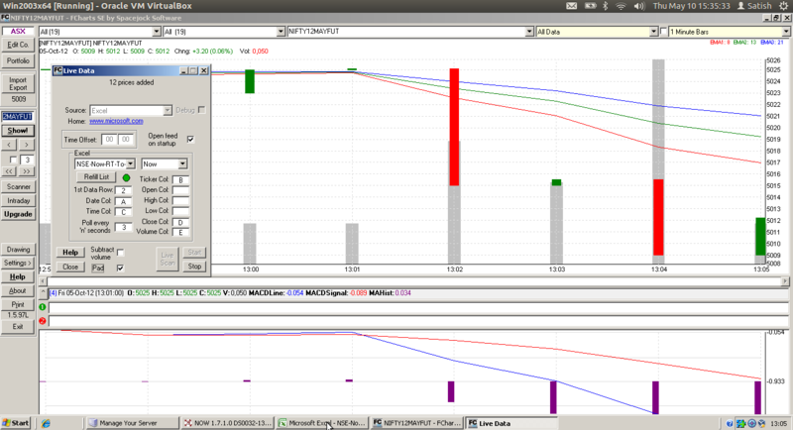

# Backfill with ODIN

1. In ODIN right click any scrip which you want backfill, click on intraday chart,
2. On chart space right click, in the sub menu click save, and click save chart as xls then you can import via import wizard.
3. Save the file in the ticker name (as it appears in Ami). Then import via ASCII is easier as the data is imported in respective ticker files in Amibroker database.
4. You can do last 5 day data and as well eod. In odin tick data available for 5 day only. first you need to set in Odin—tools--Preferance – Chart Preferance -- intraday chart-- type(min) 0 and intraday historic days 5. Then right-click scrip and intraday chart, then right-click in chart space save as Excel and import in AmiBroker.
5. You need to set, in Odin, click tools-preference-chart preference tab and set there what you want and do previous explained steps

**Method given by Rohitb**

1. Select the scrip you want then go to Market>Market movement>Market movement (derivatives) or simply press CTRL+F12 for Derivatives and Market movement (Equity) or simply press SHIFT+F12 for Equity
2. **You may/will see a box opening asking for different settings just put 1 minute time interval and hit ok**
3. Another window will open showing you time, open, high, low, close, volume, value, ATP
4. Right click in that box and select copy
5. Now Open one more blank workbook in ms excel and there click on cell A1 and right click it and select paste
6. You will see the data from the market movement pasted to excel. Now add 1 blank columns before time column by click right clicking A which is on the top of the column and selecting Insert
7. Now type date in B1 which is blank. Type your ticker name which should be exactly the same in amibroker in cell a2 and date which is current date in b2. fill the entire columns A and B with Ticker and Date till the line where the other data ends
8. Now right click the C column which is time in 12 hour format and select format cells
9. Iin format cells box under tab Numbers select time and in type select 13:30:55 ie the 24 hour format. now click ok. you will see the time in 24 hour format
10. Save this workbook as csv.
11. Do this for other scrips
12. Now in amibroker go to file>import wizard click pick files button. select the file/files you just created. then hit next button
13. In column 1 select ticker, column 2 select dmy,mdy,ymd as per the date you have manually typed in excel i use dmy format, column 3 time, column 4 open,column 5 high column 6 low,column 7 close. select more columns and in column 8 select volume. for columns 9,10,11,12 select skip.
14. Now hit next button. Save **this format as ‘ODIN format’.**
15. Now hit finish button. Data will be imported.
16. **Since everything is set, you can import other scrips thru ASCII importing using ‘ODIN format’ that you created.**
17. For same day backfill, use RTOdin.

# Backfill with Data Downloader

1. Data Downloader is created by Joydeep Mitra and it is hosted on Volumedigger.com.
2. A video is hosted on You tube for backfill. Link is here- <http://youtu.be/A65Si2KpK_s>
3. Apart from the video, do following settings in Data Downloader

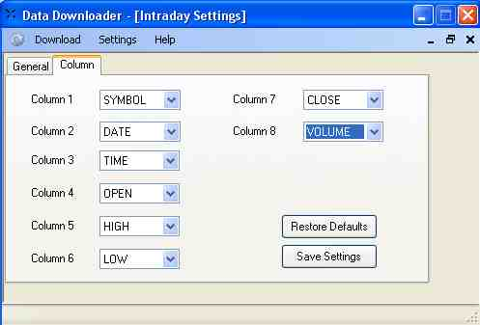

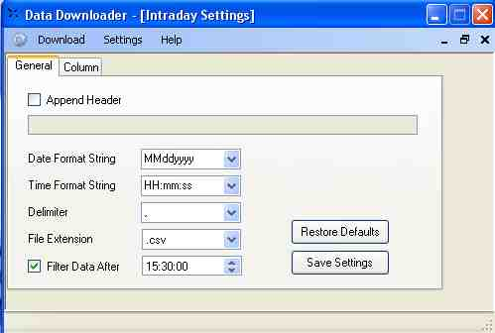

1. You can link Nest sheet the symbol will be RELIANCE-EQ, use following formula :

=IF(RIGHT(RTD!A13,3)="FUT",RTD!F13&"_F1",IF(RIGHT( RTD!A13,3)="-EQ",RTD!F13&"",RTD!A13))

1. and now the symbol will exact match of NSE symbol i.e. RELIANCE,
2. after that using © Joydeep Mitra DataDownloader,

format the intraday download as per nest column along with date i.e. dd/MM/yyyy ,

1. Edit google intraday.txt. Add the scrips (symbol should be exact as per NSE along with .NSE i.e. RELIANCE.NSE) ,
2. Download intraday data from ->INTRADAY->GOOGLE ,
3. Import all txt files in amibroker using import wizard. Save the format as “Google Intraday”.
4. BINGO all scrips backfill done in seconds.
5. Next time use “Google Intraday” format and import ASCII.

# Troubleshooting

1. I am not too good in computer related stuff, please help me.

You need not be good in computers to follow this. Follow all the instructions. If you do not understand any instruction, ask me. Sorry, I cannot do spoon feeding. Please help yourself first and thereafter I will help you.

1. I did everything as per instructions but I am not getting charts. Please help.

What do you mean by that. I cannot help you with one line information. Check whether you followed all the steps as given. Give me the exact step where you are not getting desired results and ask specific question.

1. Backfill is not happening.

What do you mean by that. I cannot help you like that. Check whether you followed all the steps as given and ask specific question. You do database setting only once. Be sure that you give same database path to RT utility and Backfill utility.